Web Application Tutorial: Talented Europe for Educational Institutions

Educational Institutions

This document explains the use of the web application [talentedeurope.eu](https://talentedeurope.eu/) from the point of view of educational institutions.

Registration

The first step to register an educational institution in the Talented Europe application is to click on the Sign up button.

**Click**



Afterwards, you need to select an icon corresponding to institutions.

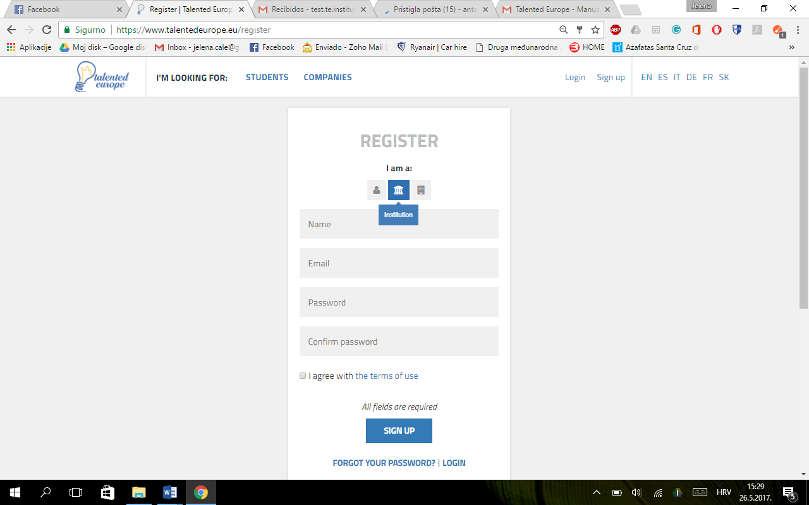

**Click**

**Click**

Next, you have to provide the name of the educational institution, an email and a password (with its subsequent confirmation). Terms of use have to be accepted.

Pressing the Sign up button, the initial registration process ends.

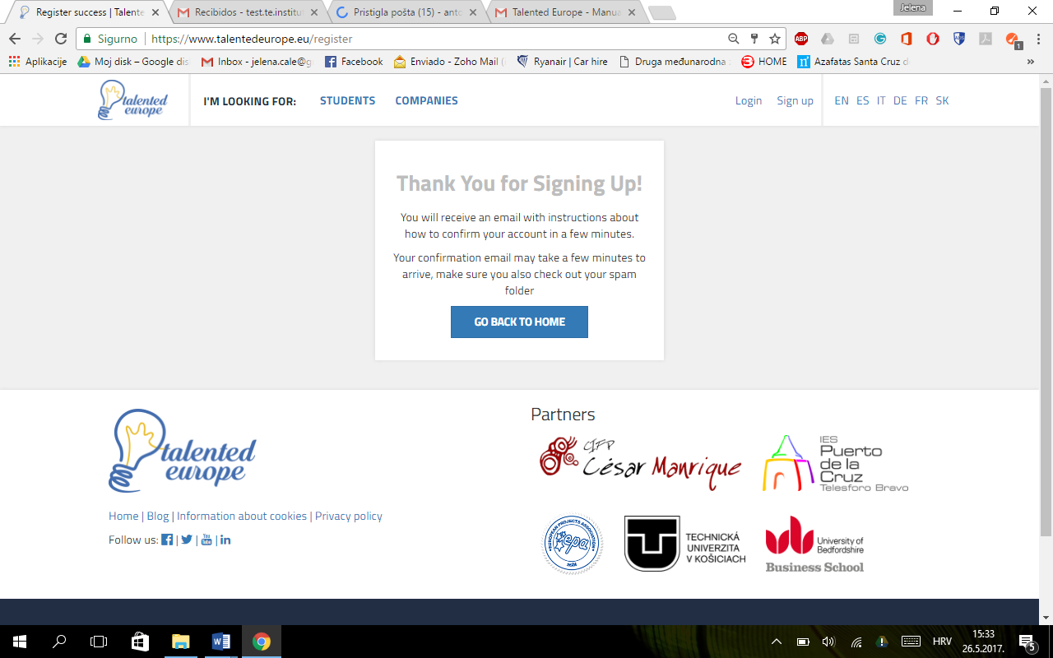

In a short time you will receive an email.

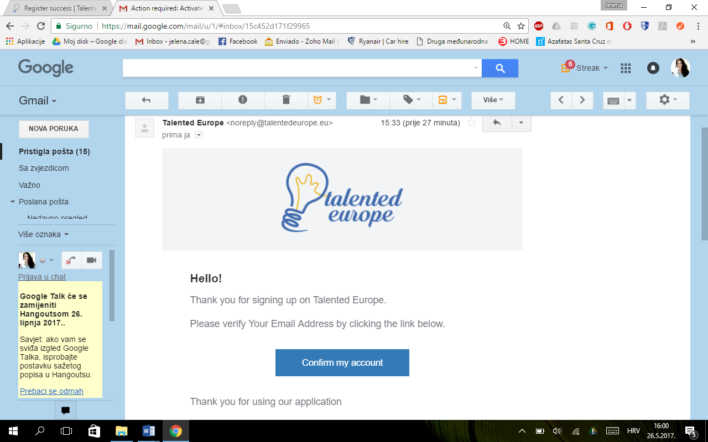

**Click**

When you click on the Confirm my account button, **a screen will be displayed where you have to confirm that the activation of the account was correct** and that it is possible to log in to the Talented Europe.

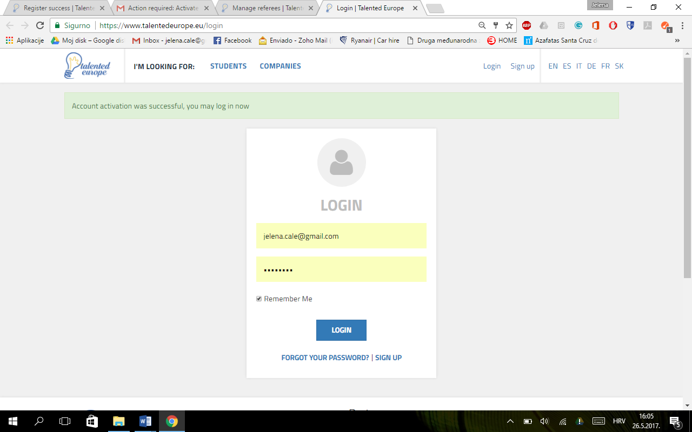

**Click**

@

In order to log in you have to enter email and password used during the registration. Upon the first login the following screen will appear in which it is stated that you have to complete your profile filling in the mandatory fields, which enables you to add email addresses of the referees (professors, teachers) at your educational institution (university, school), who can then validate their talented students.To do this, press the Set up my profile button.

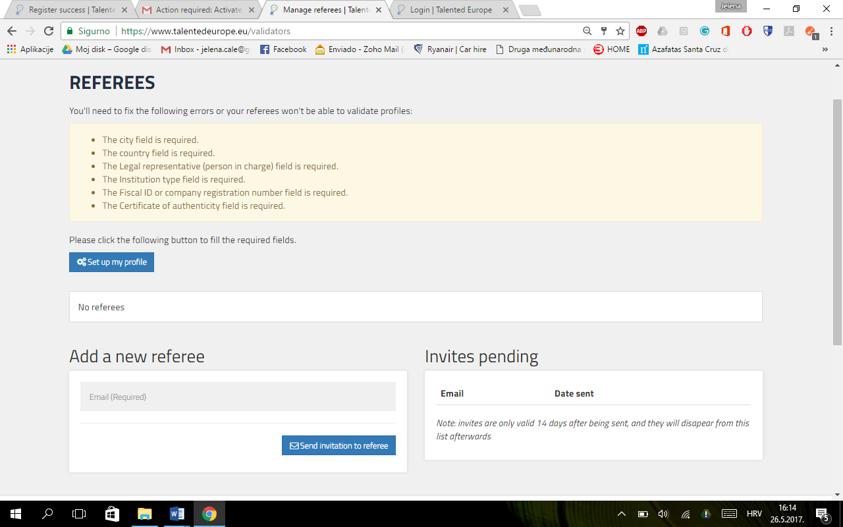

**Click**

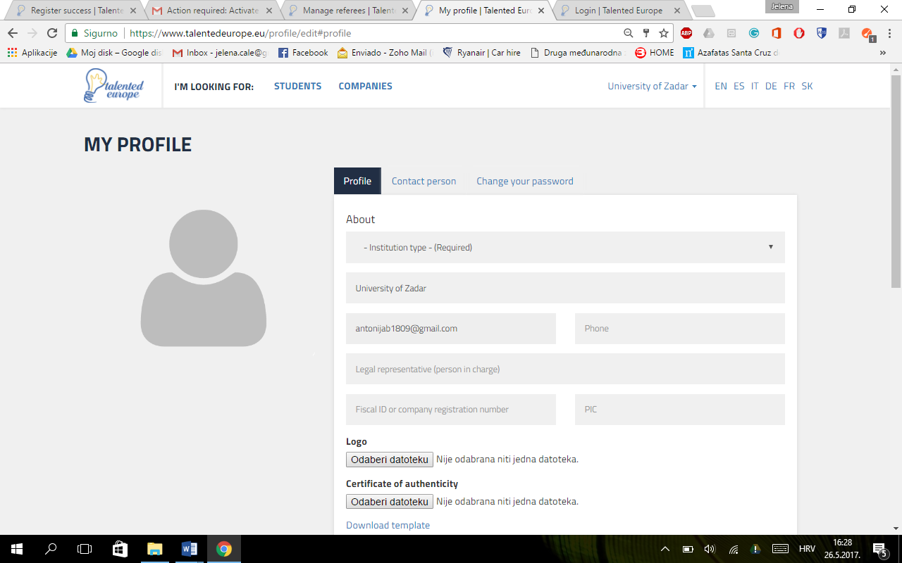

Choose File

**Click**

@

*Name of the Educational Institution*

No file has been chosen

No file has been chosen

Choose File

* You will see the data corresponding to the **Profile** tab. First, you have to choose the type of institution, such as:
* Secondary school
* Vocational training
* University/College
* The name and the email of the institution are already filled out as they have been entered during the registration. The following information has to be completed:
* Telephone number
* Legal representative of the institution
* Tax identification number
* PIC (Participant Identification Code). Number identifying the institution when submitting applications for the Erasmu+ project.

🡪 The **logo** of the institution should be uploaded in the *jpg* or *png* format. Doing this is important because it will allow the educational institution to be visible on the platform.

🡪 In order to obtain a sufficient level of certainty that the educational institution indeed is as claimed, a signed certificate has to be submitted and, if possible, stamped by the legal representative. The template of this document can be downloaded at the indicated link.

Continuing with the completion of the profile, the following fields appear:

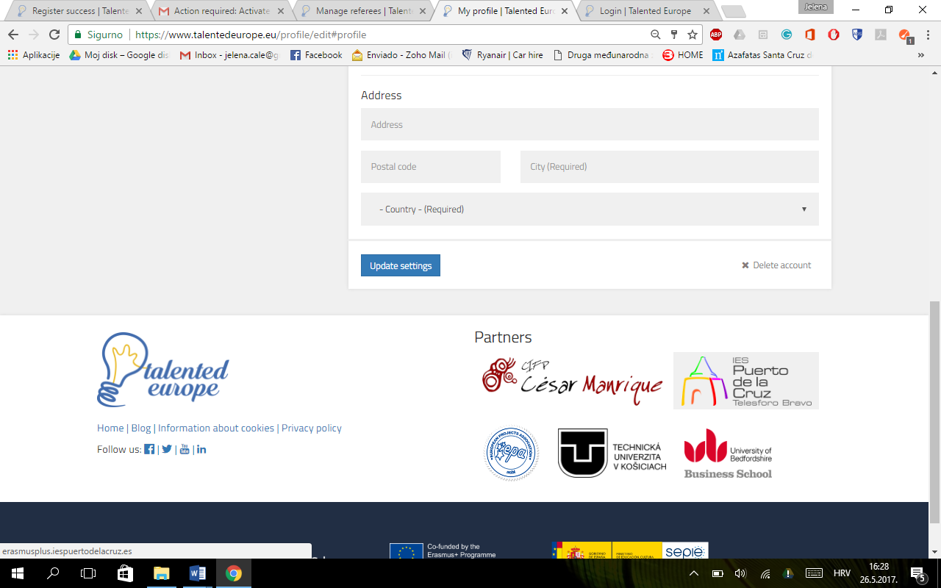

**Click**

Address, postal code of the institution, city and country are required fields, which need to be filled.

Whenever a modification is made to the profile, you have to click on the Update settings button. Otherwise, the changes will not be saved.

You can also delete the institution's account by clicking on Delete account.

If you click on the Contact Person tab, you can enter a name and an email of the user responsible for receiving notifications from the Talented Europe platform.

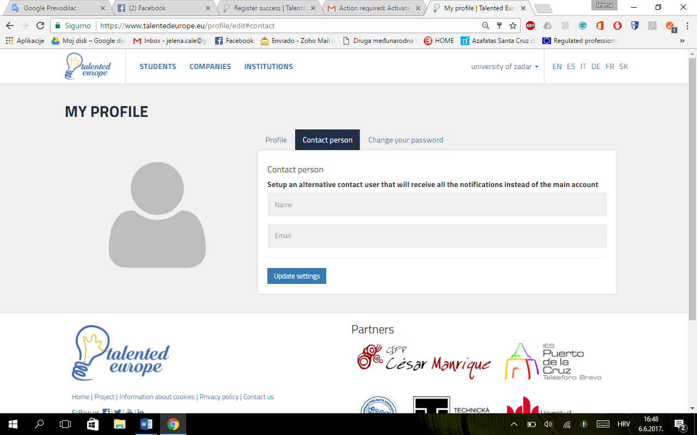

**Click**

Again, it is important to press the Update settings button. Otherwise, the changes will not be saved.

Finally, in the Change your password tab, you can change the password of the account associated with the educational institution.

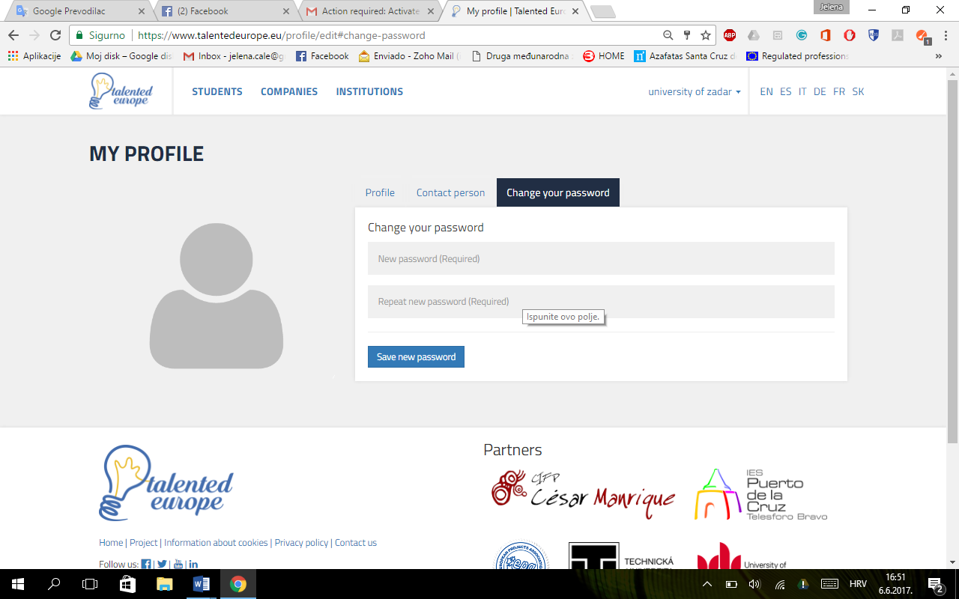

**Click**

It is important to press the Save new password button for the changes to take effect.

At any time you can change the profile of your educational institution by clicking on the upper right area, where it says the name of your educational institution and select the settings option.

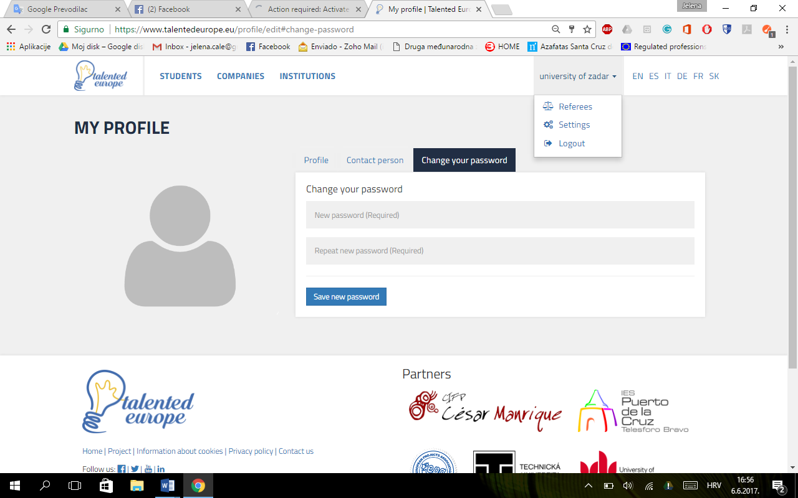

**Click**

*Name of the Educational Institution*

Once the educational institution's profile has been completed, the next step would be to add referees to your educational institution so that the students can be correctly validated, and thus achieve an adequate visibility on the Talented Europe platform.

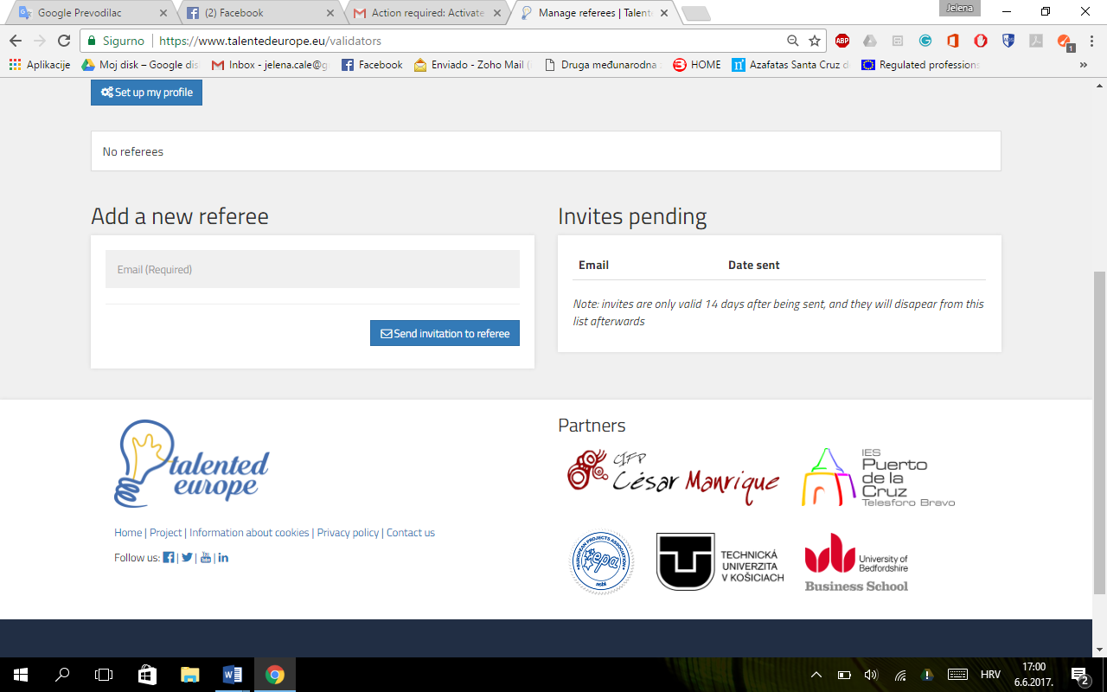

**Click**

Login

To log in to the Talented Europe platform, access the <https://www.talentedeurope.eu/> and click on Login:



**Click**

The following form will appear, where you have to enter email and password used upon the institution's registration or the information of the person who is authorized to receive notifications:

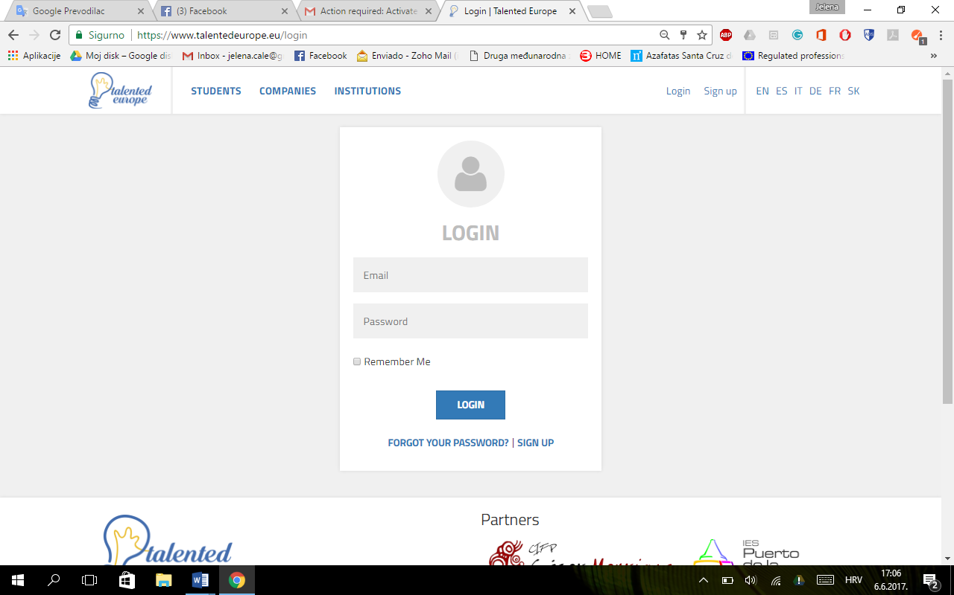

**Click**